**DATA COMMUNICATION AND NETWORK**  
Documentation  
02-JUNE-2021

**______________________________________________________________________________**

Project By:  
Abdul Wasay 1812254

Components and Device

100 Campus:

|  |  |  |  |
| --- | --- | --- | --- |
|  | PC's | Printers | Servers |
| CS Lab | 58 | 2 | 1 |
| Lab 3 | 38 | 2 | 1 |
| Lab 4 | 35 | 2 | 0 |
| Lab 5 | 35 | 2 | 1 |
| Smart Lab | 40 | 1 | 0 |
| Gaming Lab | 9 | 2 | 0 |
| Classrooms | 20 | 0 | 0 |
| Faculty | 30 | 0 | 0 |
| Academic Department | 5 | 3 | 0 |
| Administration Department | 4 | 0 | 0 |
| IT Department | 10 | 2 | 0 |

154 Campus:

|  |  |  |  |
| --- | --- | --- | --- |
|  | PC’s | Printers | Servers |
| Mechatronic Lab | 15 | 1 | 0 |
| Classrooms | 8 | 0 | 0 |
| Faculty | 18 | 2 | 0 |
| Administration Department | 2 | 0 | 0 |
| Academics Department | 1 | 1 | 0 |

153 Campus:

|  |  |  |  |
| --- | --- | --- | --- |
|  | PC’s | Printers | Servers |
| Classrooms | 6 | 0 | 0 |
| Admission Department | 8 | 3 | 0 |
| Academics Department | 1 | 1 | 0 |

Network Diagram (Logical Topology)

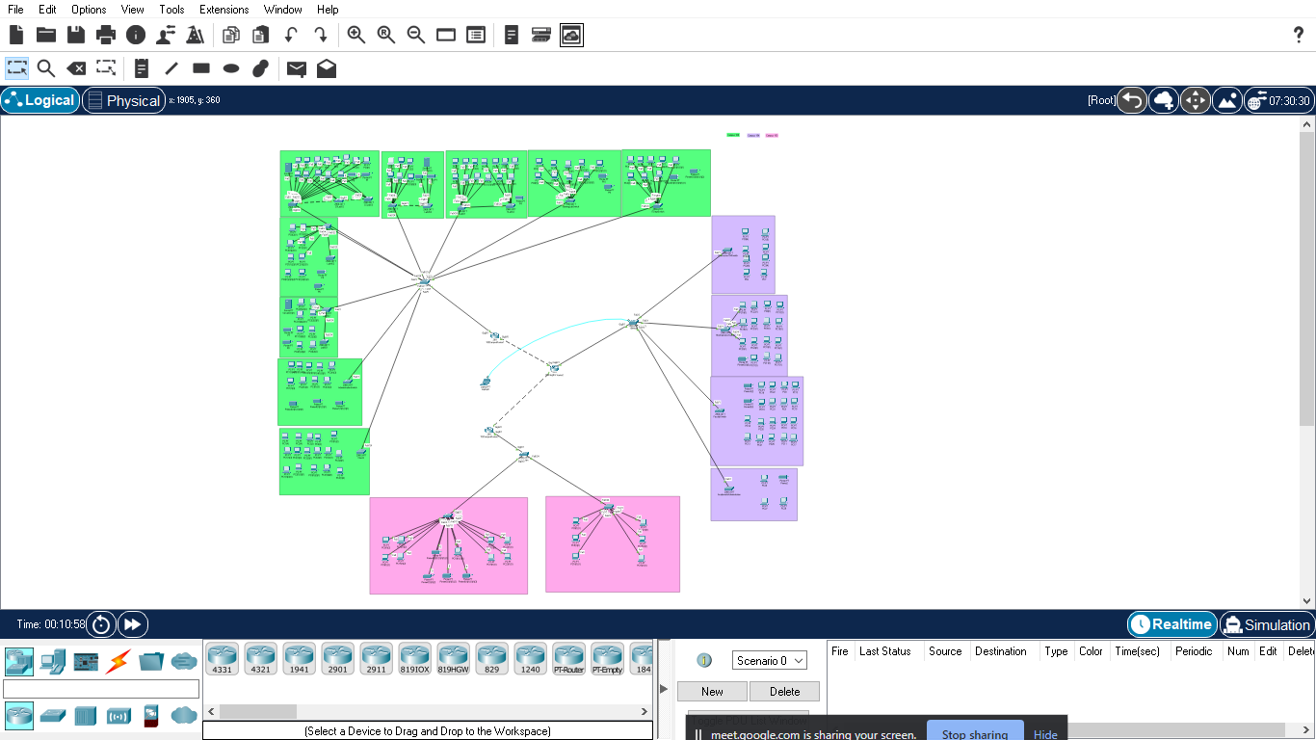

**Addressing Table:**

|  |  |  |  |  |
| --- | --- | --- | --- | --- |
| **Device** | **Interface** | **IP Address** | **Subnet Mask** | **Default Gateway** |
| 100CampusRouter1 | 0/0.1 | 181.22.81.1 | 255.255.255.128 | - |
|  | 0/0.2 | 181.22.81.161 | 255.255.255.192 | - |
|  | 0/0.3 | 181.22.54.145 | 255.255.255.192 | - |
|  | 0/0.4 | 181.22.81.129 | 255.255.255.224 | - |
|  | 0/0.5 | 181.22.81.65 | 255.255.255.128 | - |
|  | 0/0.6 | 181.22.61.1 | 255.255.255.240 | - |
|  | 0/0.7 | 181.22.61.129 | 255.255.255.128 | - |
|  | 0/0.8 | 181.22.61.193 | 255.255.255.128 | - |
|  | 0/0.9 | 181.22.54.1 | 255.255.255.128 | - |
|  | 0/0.10 | 181.22.54.65 | 255.255.255.128 | - |
|  | 0/0.11 | 181.22.54.129 | 255.255.255.192 | - |
|  | 0/0.12 | 181.22.11.1 | 255.255.255.224 | - |
|  | 0/0.13 | 181.22.11.33 | 255.255.255.192 | - |
| 100 Campus | Vlan 2 | 181.22.81.2 | 255.255.255.128 | 181.22.81.1 |
|  | Vlan 3 | 181.22.81.162 | 255.255.255.192 | 181.22.81.161 |
|  | Vlan 4 | 181.22.54.146 | 255.255.255.192 | 181.22.54.145 |
|  | Vlan 5 | 181.22.81.130 | 255.255.255.224 | 181.22.81.129 |
|  | Vlan 6 | 181.22.81.66 | 255.255.255.128 | 181.22.81.65 |
|  | Vlan 7 | 181.22.61.2 | 255.255.255.240 | 181.22.61.1 |
|  | Vlan 8 | 181.22.61.130 | 255.255.255.128 | 181.22.61.129 |
|  | Vlan 9 | 181.22.61.194 | 255.255.255.128 | 181.22.61.193 |
|  | Vlan 10 | 181.22.54.2 | 255.255.255.128 | 181.22.54.1 |
|  | Vlan 11 | 181.22.54.66 | 255.255.255.128 | 181.22.54.65 |
|  | Vlan 12 | 181.22.54.130 | 255.255.255.192 | 181.22.54.129 |
| Faculty | Vlan 2 | 181.22.81.4 | 255.255.255.128 | 181.22.81.1 |
| Faculty2 | Vlan 2 | 181.22.81.6 | 255.255.255.128 | 181.22.81.1 |
| Administration | Vlan 3 | 181.22.81.164 | 255.255.255.192 | 181.22.81.161 |
| IT Department | Vlan 4 | 181.22.54.147 | 255.255.255.192 | 181.22.54.145 |
| Printer 1 | Vlan 4 | 181.22.54.148 | 255.255.255.192 | 181.22.54.145 |
| Printer 2 | Vlan 4 | 181.22.54.149 | 255.255.255.192 | 181.22.54.145 |
| Academics | Vlan 5 | 181.22.81.133 | 255.255.255.224 | 181.22.81.129 |
| Printer 1 | Vlan 5 | 181.22.81.136 | 255.255.255.224 | 181.22.81.129 |
| Printer 2 | Vlan 5 | 181.22.81.137 | 255.255.255.224 | 181.22.81.129 |
| Printer 3 | Vlan 5 | 181.22.81.138 | 255.255.255.224 | 181.22.81.129 |
| Classrooms | Vlan 6 | 181.22.81.69 | 255.255.255.128 | 181.22.81.65 |
| CSLab | Vlan 7 | 181.22.61.3 | 255.255.255.240 | 181.22.61.1 |
| CSLab1 | Vlan 7 | 181.22.61.4 | 255.255.255.240 | 181.22.61.1 |
| CSLab2 | Vlan 7 | 181.22.61.5 | 255.255.255.240 | 181.22.61.1 |
| Printer 1 | Vlan 7 | 181.22.61.6 | 255.255.255.240 | 181.22.61.1 |
| Printer 2 | Vlan 7 | 181.22.61.7 | 255.255.255.240 | 181.22.61.1 |
| Server 1 | Vlan 7 | 181.22.61.8 | 255.255.255.240 | 181.22.61.1 |
| Lab3 | Vlan 8 | 181.22.61.131 | 255.255.255.128 | 181.22.61.129 |
| Lab3s1 | Vlan 8 | 181.22.61.132 | 255.255.255.128 | 181.22.61.129 |
| Printer 1 | Vlan 8 | 181.22.61.133 | 255.255.255.128 | 181.22.61.129 |
| Printer 2 | Vlan 8 | 181.22.61.134 | 255.255.255.128 | 181.22.61.129 |
| Server 1 | Vlan 8 | 181.22.61.135 | 255.255.255.128 | 181.22.61.129 |
| Lab4 | Vlan 9 | 181.22.61.195 | 255.255.255.128 | 181.22.61.193 |
| Lab4s1 | Vlan 9 | 181.22.61.196 | 255.255.255.128 | 181.22.61.193 |
| Printer 1 | Vlan 9 | 181.22.61.197 | 255.255.255.128 | 181.22.61.193 |
| Printer 2 | Vlan 9 | 181.22.61.198 | 255.255.255.128 | 181.22.61.193 |
| Lab5 | Vlan 10 | 181.22.54.3 | 255.255.255.128 | 181.22.54.1 |
| Lab5s1 | Vlan 10 | 181.22.54.4 | 255.255.255.128 | 181.22.54.1 |
| Printer 1 | Vlan 10 | 181.22.54.5 | 255.255.255.128 | 181.22.54.1 |
| Printer 2 | Vlan 10 | 181.22.54.6 | 255.255.255.128 | 181.22.54.1 |
| Server 1 | Vlan 10 | 181.22.54.7 | 255.255.255.128 | 181.22.54.1 |
| SmartLab | Vlan 11 | 181.22.54.67 | 255.255.255.128 | 181.22.54.65 |
| SmartLabs1 | Vlan 11 | 181.22.54.68 | 255.255.255.128 | 181.22.54.65 |
| Printer 1 | Vlan 11 | 181.22.54.69 | 255.255.255.128 | 181.22.54.65 |
| GamingLab | Vlan 12 | 181.22.54.131 | 255.255.255.192 | 181.22.54.129 |
| Printer 1 | Vlan 12 | 181.22.54.132 | 255.255.255.192 | 181.22.54.129 |
| Printer 2 | Vlan 12 | 181.22.54.133 | 255.255.255.192 | 181.22.54.129 |
| 153 Campus | Vlan 5 | 181.22.81.132 | 255.255.255.224 | 181.22.81.129 |
|  | Vlan 6 | 181.22.81.68 | 255.255.255.128 | 181.22.81.65 |
|  | Vlan 14 | 181.22.11.34 | 255.255.255.192 | 181.22.11.33 |
| Academics | Vlan 5 | 181.22.81.135 | 255.255.255.224 | 181.22.81.129 |
| Printer 1 | Vlan 5 | 181.22.81.140 | 255.255.255.224 | 181.22.81.129 |
| Classroom | Vlan 6 | 181.22.81.71 | 255.255.255.128 | 181.22.81.65 |
| AdmissionDept | Vlan 14 | 181.22.11.35 | 255.255.255.192 | 181.22.11.33 |
| Printer1 | Vlan 14 | 181.22.11.36 | 255.255.255.192 | 181.22.11.33 |
| Printer2 | Vlan 14 | 181.22.11.37 | 255.255.255.192 | 181.22.11.33 |
| Printer3 | Vlan 14 | 181.22.11.38 | 255.255.255.192 | 181.22.11.33 |
| 154 Campus | Vlan 2 | 181.22.81.3 | 255.255.255.128 | 181.22.81.1 |
|  | Vlan 3 | 181.22.81.163 | 255.255.255.192 | 181.22.81.161 |
|  | Vlan 5 | 181.22.81.131 | 255.255.255.224 | 181.22.81.129 |
|  | Vlan 6 | 181.22.81.67 | 255.255.255.128 | 181.22.81.65 |
|  | Vlan 13 | 181.22.11.2 | 255.255.255.224 | 181.22.11.1 |
| Faculty | Vlan 2 | 181.22.81.5 | 255.255.255.128 | 181.22.81.1 |
| Printer 1 | Vlan 2 | 181.22.81.7 | 255.255.255.128 | 181.22.81.1 |
| Printer 2 | Vlan 2 | 181.22.81.8 | 255.255.255.128 | 181.22.81.1 |
| Admin | Vlan 3 | 181.22.81.163 | 255.255.255.192 | 181.22.81.161 |
| Academics | Vlan 5 | 181.22.81.134 | 255.255.255.224 | 181.22.81.129 |
| Printer 1 | Vlan 5 | 181.22.81.140 | 255.255.255.224 | 181.22.81.129 |
| Classroom | Vlan 6 | 181.22.81.70 | 255.255.255.128 | 181.22.81.65 |
| MechatronicLab | Vlan 13 | 181.22.11.3 | 255.255.255.224 | 181.22.11.1 |
| Printer 1 | Vlan 13 | 181.22.11.4 | 255.255.255.224 | 181.22.11.1 |

|  |  |  |  |  |  |  |
| --- | --- | --- | --- | --- | --- | --- |
| Vlan Name | Main Switch | Access Ports | Switch Name | Access Ports | Campus Name | Trunk Ports |
| Classrooms | 100 | fa 0/5 | ClassS | fa 0/1 - fa 0/24 | 100 | gi 0/1 - gi 0/2 |
|  | 153 | fa 0/1 | Classrooms153Switch | fa 0/1 - fa 0/24 | 153 | gi 0/2 |
|  | 154 | fa 0/3 | Classrooms154Switch | fa 0/1 - fa 0/24 | 154 | gi 0/1 - gi 0/2 |
| CSLab | 100 | fa 0/6 | CslabS1 | fa 0/1 - fa 0/24 | 100 | gi 0/1 - gi 0/2 |
|  |  |  | CslabS2 | fa 0/1 - fa 0/24 |  |  |
|  |  |  | CslabS3 | fa 0/1 - fa 0/24 |  |  |
| Lab3 | 100 | fa 0/7 | Lab3S1 | fa 0/1 - fa 0/24 | 100 | gi 0/1 - gi 0/2 |
|  |  |  | Lab3S2 | fa 0/1 - fa 0/24 |  |  |
| Lab4 | 100 | fa 0/8 | Lab4S1 | fa 0/1 - fa 0/24 | 100 | gi 0/1 - gi 0/2 |
|  |  |  | Lab4S2 | fa 0/1 - fa 0/24 |  |  |
| Lab5 | 100 | fa 0/9 | Lab5S1 | fa 0/1 - fa 0/24 | 100 | gi 0/1 - gi 0/2 |
|  |  |  | Lab5S2 | fa 0/1 - fa 0/24 |  |  |
| SmartLab | 100 | fa 0/10 | SmartLabS1 | fa 0/1 - fa 0/24 | 100 | gi 0/1 - gi 0/2 |
|  |  |  | SmartLabS2 | fa 0/1 - fa 0/24 |  |  |
| GamingLab | 100 | fa 0/11 | GamingLabSwitch | fa 0/1 - fa 0/24 | 100 | gi 0/1 - gi 0/2 |
| MechatronicLab | 154 | fa 0/2 | MechatronicsSwitch | fa 0/1 - fa 0/24 | 154 | gi 0/1 - gi 0/2 |
| Admin | 100 | fa 0/2 | AdministrationSwitch | fa 0/1 - fa 0/24 | 100 | gi 0/1 - gi 0/2 |
|  | 154 | fa 0/5 | Admin | fa 0/1 - fa 0/24 | 154 | gi 0/1 - gi 0/2 |
| Academics | 100 | fa 0/4 | Academics | fa 0/1 - fa 0/24 | 100 | gi 0/1 - gi 0/2 |
|  | 153 | fa 0/3 | Admission&AcademicSwitch | fa 0/1 - fa 0/24 | 153 | gi 0/2 |
|  | 154 | fa 0/4 | Academic&Administration | fa 0/1 - fa 0/24 | 154 | gi 0/1 - gi 0/2 |
| Faculty | 100 | fa 0/1 | Faculty | fa 0/1 - fa 0/24 | 100 | gi 0/1 - gi 0/2 |
|  |  |  | Faculty1 | fa 0/1 - fa 0/24 |  |  |
|  | 154 | fa 0/1 | FacultySwitch | fa 0/1 - fa 0/24 | 154 | gi 0/1 - gi 0/2 |
| IT Department | 100 | fa 0/3 | ITDepartmentSwitch | fa 0/1 - fa 0/24 | 100 | gi 0/1 - gi 0/2 |